Report No: 009
Tick: First time/Recurring

INCIDENT REPORT
(To be filled by Area in charge/supervisor within 24 hrs.) Annexure 1
PART A (Incident details)
1. INCIDENT INFORMATION
DATE 31-12-2022 | TIME: 04.30 PM | Day of week  Sun M T W T F √Sat | Shift  A B C √G
2. Plant/Dept.: Mechanical Location of Incident: Boiler
3. Incident category: √Injury Fire Property/Equip. Damage Chem. spill/overflow others ---------
4. Person Injured: Company Employee Contractor Employee Visitor
Nature of injury | Bruising | Dislocation | Other (specify) | Injured part of body
Strain/ sprain | Scratch/Abrasion | Internal
Fracture | Amputation | Foreign body
Laceration/Cut | Burn/ scald | Chem. reaction
5. Name of Injured:
Name | E.No. /Contractor’s Name | Age  (Years) | Experience  (Years) | Designation
Mr. Vijesh yadaw | Greensol | 42 | 5 | Rigger

6. State, which Object/ Equipment/ Chemical involved: Channel
7. Description of Incident: (Attach separate sheet if space is insufficient)

On dated 31-12-2022 at 4.30 PM Mr. Vijesh yadaw was doing gas cutting work, he was cutting the scrap for fabrication work. While performing the activity, Mr. Vijesh underestimated the suspended load which collapsed after cutting, the steel structure (channel) suddenly fell on his leg after cutting as worker was using steel toe safety shoe. He met with minor cut injury.
Immediately first aid provided and sent to the hospital for further check-up and treatment.

8. What type of activity was being performed Cutting of Scrap Material (channel) ___________________________________________________________________________
9. Check the following for the Safety Precautions related to the incident:
PPE Usage | Yes/No
SOP/Work Instruction Available | Yes/No
SOP/Work Instruction Adequate | Yes/No
Training Provided | Yes/No
Any Other (Please specify):
10. State the probable reasons for this incident: √Unsafe Act/ Practice √ Unsafe Condition
Describe details (attach additional page if space is not sufficient):
11. State whether this activity is: √ Routine Non-Routine
12. What immediate action was taken to control the incident? Stopped the work and communicated about the incident to other workers.

13. Witness of the Incident:

Name | E.No. /Contractor | Designation
Mr. Lal babu | TEPL | Rigger Forman

14. Reported by:
Name of the Shift in charge | Signature | Date | Time
Mr. Rahul Kumar

INCIDENT INVESTIGATION/ PREVENTIVE ACTION REPORT
(To be completed by the Investigation Team within specified time limit (Refer Guideline))

PART B (Incident Investigation).
1. Incident Investigation Team: To be proposed & lead by HOD.
Name of the HOD: Mr. Bino Thomas
Other Members:
Name | Dept | Signature with date
Mr. D R SAHU | SITE INCHARGE
Mr. ANZARUL ISLAM | SAFETY ENGINEER
Mr. MAHENDER PRAJAPATI | SAFETY OFFICER
Mr. Shahrukh khan | Asst. Manager
2. Injury potential:
√First Aid cases Reportable injury (*Man days Lost___)
√ Referred to Hospital Death (No of persons: __)
*To be filled after the injured person reporting back to duty. In case death it is not applicable.
3. Nature of Incident: √ Minor Medium Major.
4. In case of property damage:
Detail of property damage: _________________________________________________________
Approx. loss: Rs.______________
5. Documents reviewed: √ SOP/WI P&ID, PFD, Equip. Drawings, √ Photographs, Others___

6. Probable causes (use separate sheet if space is insufficient):
a. Immediate Causes
Using the poor technique of cutting

b. Root Causes
- Due to negligence.
- Improper handling of tools.

ROOT CAUSE ANALYSIS (Tick mark all that is applicable)
 | Unsafe Acts |  | Unsafe Conditions |  | Management Deficiencies
 | Improper work technique |  | Poor workstation design or layout |  | Lack of written procedures/policies
 | Safety rule violation |  | Congested work area |  | Safety rules not enforced
 | Improper PPE or PPE not used |  | Hazardous substances |  | Hazards not identified
 | Operating without authority |  | Fire or explosion hazard |  | PPE unavailable
 | Failure to warn or secure |  | Inadequate ventilation |  | Insufficient worker training
 | Operating at improper speeds |  | Improper material storage |  | Insufficient supervisor training
 | By-passing safety devices |  | Improper tool or equipment |  | Improper maintenance
 | Guards not used |  | Insufficient knowledge of job |  | Inadequate supervision
 | Improper loading or placement |  | Slippery conditions |  | Inadequate job planning
 | Improper lifting |  | Poor housekeeping |  | Inadequate hiring practices
 | Servicing machinery in motion |  | Excessive noise |  | Inadequate workplace inspection
 | Horseplay |  | Inadequate guarding of hazards |  | Inadequate equipment
 | Drug or alcohol use |  | Defective tools/ equipment |  | Unsafe design or construction
 | Unnecessary haste |  | Insufficient lighting |  | Unrealistic scheduling
 | Unsafe act of others |  | Inadequate fall protection |  | Poor process design
 | Other: |  | Other: |  | Other:

9. Corrective & Preventive measure Action plan: (use separate sheet if space is insufficient)

Corrective & Preventive Action Recommended | Person Responsible | Target Date
- Deployment of only skilled workers for skilled jobs. | Contractor Site Engineer | 03/01/2023
- Revision Training shall be conducted on topics:  - Importance of job-specific PPEs and uses.  - Safe handling of tools/equipment.  - Roles and responsibilities of supervisor/engineers.  - Identification of Hazard before starting the job. | Safety In-charge | 03/01/2023
- Deployment of experienced supervisor to monitor and guide the workers frequently. | Site In charge | 03/01/2023

10. Learning from incident:

PART C: Review: (Comments if any)

HOD (Department where incident occurred) |  | HOD (Proj & Engg /HR/Admin/_____) | Location Head
Signature
Date

PART D: (by EHS)
Completion Status: Completed Not completed
If not completed specify the reason (s):

Date: ________________________Name: __________________Signature:______________________

Copy to: a) HOD in whose dept incident occurs, b) Unit Head/ Site EHS Head, c) Site HR Head (in case of injury) d) Corporate EHS head.

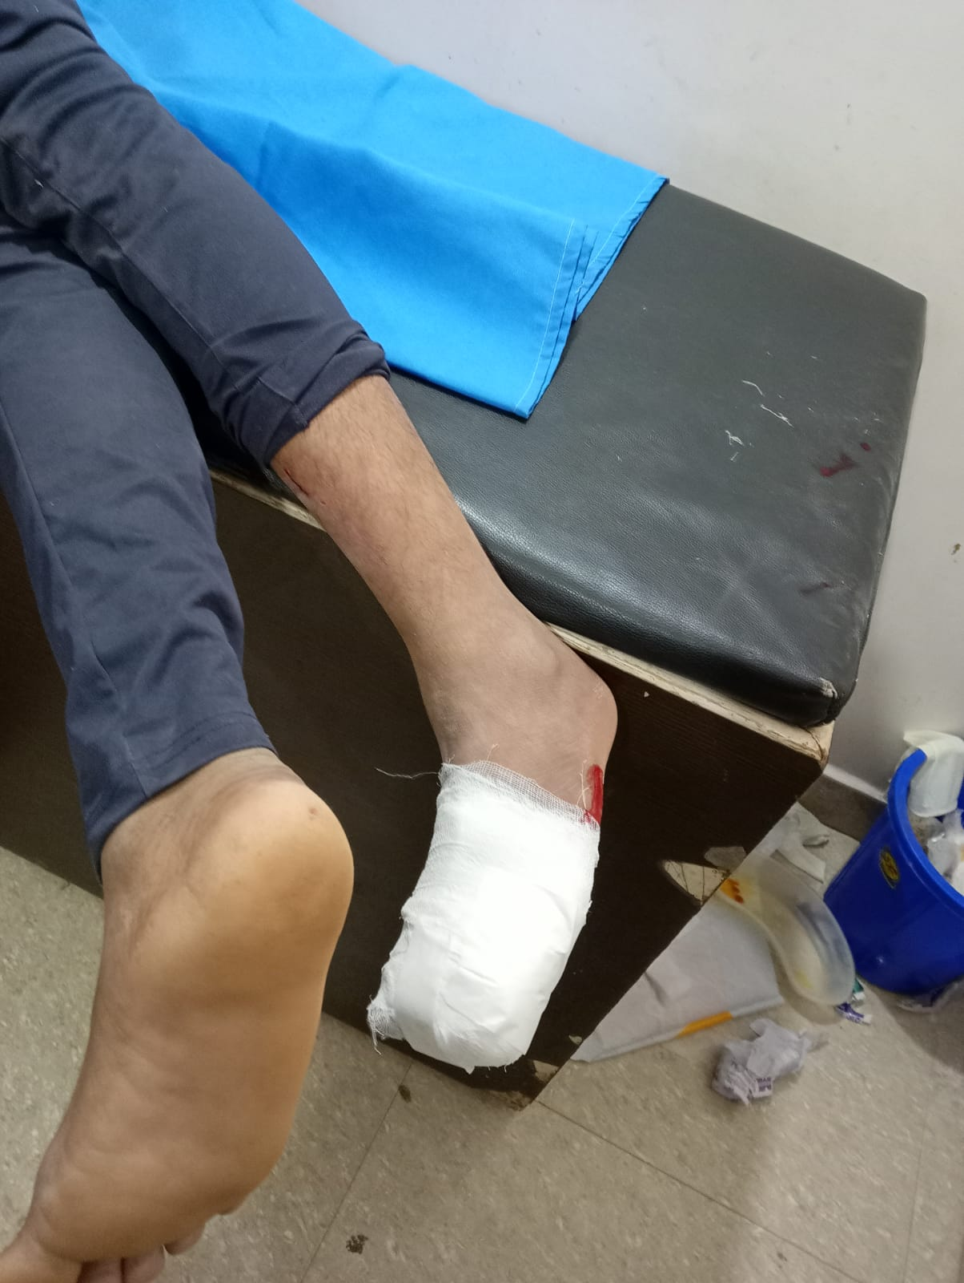 | 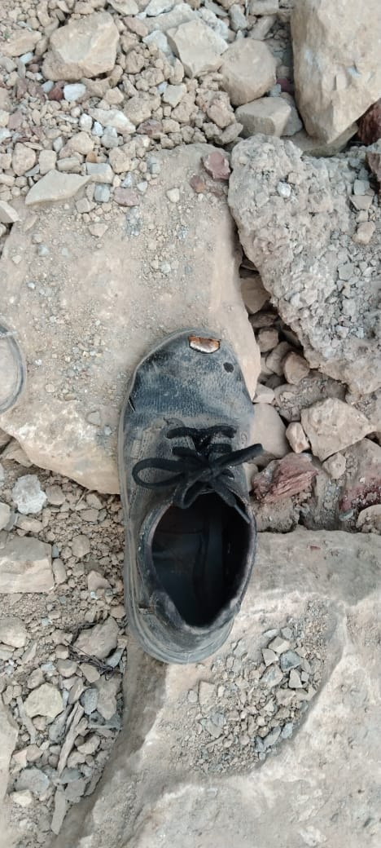

End of the Report.

